ABOUT THIS SECTION

Odour assessments are conducted for a variety of reasons, and the tools used to conduct the assessment will depend on its purpose. There are a wide variety of odour assessment tools and approaches available and there is no one standard method or approach for conducting an odour assessment. There are a number of elements to an assessment (e.g., source odour measurements, dispersion modelling, ambient air testing and monitoring) and an odour assessment may include a combination of these elements.

* [**Types of Odour Assessments**](http://casahome.org/CurrentInitiatives/GoodPracticesGuideforOdourManagementinAlberta/OdourAssessments.aspx#types)
* [**Assessments Based on Ambient Monitoring**](http://casahome.org/CurrentInitiatives/GoodPracticesGuideforOdourManagementinAlberta/OdourAssessments.aspx#ambientassessment)
* [**Assessments Based on Source Sampling**](http://casahome.org/CurrentInitiatives/GoodPracticesGuideforOdourManagementinAlberta/OdourAssessments.aspx#assessmentsource)
* [**Inventory Assessment**](http://casahome.org/CurrentInitiatives/GoodPracticesGuideforOdourManagementinAlberta/OdourAssessments.aspx#inventoryassessment)
* [**Assessments Based on Dispersion Modelling**](http://casahome.org/CurrentInitiatives/GoodPracticesGuideforOdourManagementinAlberta/OdourAssessments.aspx#dispersion)
* [**Odour Assessment Tools and Practices**](http://casahome.org/CurrentInitiatives/GoodPracticesGuideforOdourManagementinAlberta/OdourAssessments.aspx#tools)
* [**Odour Assessment ‘Tools Use’ Guide**](http://casahome.org/CurrentInitiatives/GoodPracticesGuideforOdourManagementinAlberta/OdourAssessments.aspx#toolsuse)

The information in this section was summarized from this report, which includes more detailed information and all references cited:

* [***Review of Odour Assessment Tools and Practices for Alberta***](http://casahome.org/LinkClick.aspx?fileticket=P-9teU5NWU4%3d&portalid=0&timestamp=1436887677750) which was prepared for the Clean Air Strategic Alliance by Millennium EMS Solutions Ltd., and Environmental Odour Consulting.

TYPES OF ODOUR ASSESSMENTS

Odour assessments are generally performed to:

* Verify and investigate odour complaints.
* Comply with conditions outlined in operating/industrial permits, including the verification of emissions.
* Determine compliance with odour legislation.
* Assess long-term odour exposure levels in an area.
* Rank potential odour sources for mitigation purposes.
* Determine background odour concentrations before building a new facility.
* Determine the off‐site odour impact from existing operations.
* Determine the expected changes in off‐site odours resulting from new facilities, expansion of existing facilities or other operational changes.

How an odour assessment is performed will depend on its purpose. For instance, if the purpose is to assess compliance with an industrial permit then a measurement of source emissions might be required. If the purpose is to investigate odour complaints or to verify compliance with an existing ambient air quality standard, then the assessment may require ambient air monitoring. Other considerations include assessments associated with existing, proposed, modified, or expanding facilities or operations. In some cases, odour assessments may combine a number of different approaches.

There is no standard method for odour assessments. They may include one or more assessment components (e.g., source odour measurements, dispersion modelling, ambient air testing and monitoring).

Odour assessments may also vary in level of detail, which will depend on factors specific to the situation being assessed (e.g., risk of odour impact, proximity of receptors, the scale of the proposed activity, nature of the proposed development and its potential odour sources).

* Screening assessments typically involve simple, low‐cost approaches designed to identify some general characteristics of a potential or existing odour issue. Examples include non‐analytical methods such as source inventories, complaint reviews, ambient measurements (such as some types of integrative monitors) or screening dispersion models.
* Detailed assessments are designed to provide more data and a more rigorous understanding of the problem, and could involve olfactometry, continuous emission measurements or advanced dispersion models.

As part of an odour assessment, an odour baseline establishes odour concentrations prior to development or activity changes that may result in changed odour emissions. It should also survey the locations of sensitive receptors in the area, such as residences, schools and recreational facilities. Results from the odour baseline, along with the changed emission profile of the facility or activity, may affect the design of the facility or nature of the activity with respect to process conditions, odour control equipment, or emission siting and timing.

|  |
| --- |
| THE FOLLOWING APPROACHES MIGHT BE USED FOR CONDUCTING ODOUR ASSESSMENTS:  [**Ambient odour assessment**](http://casahome.org/CurrentInitiatives/GoodPracticesGuideforOdourManagementinAlberta/OdourAssessments.aspx#ambientassessment):Includes off‐site odour monitoring techniques such as real-time ambient odour olfactometry monitoring, community odour surveys, electronic noses, continuous or semi-continuous monitoring for specific compounds or groups of compounds, odour mapping, investigation of community responses to surveys, or subjective odour event diaries.  [**Source odour assessment:**](http://casahome.org/CurrentInitiatives/GoodPracticesGuideforOdourManagementinAlberta/OdourAssessments.aspx#assessmentsource) Includes odour and/or specific odorant measurement/estimation at potential odour sources at the facility and determination of odour emissions rates for each source. The emission rates are then used to predict off‐site odour concentrations, generally using dispersion modelling assessment. The odour sources can be a point source (such as a stack or vent), an area source (such as a lagoon or pond) or a fugitive source (such an open door or truck loading area involving odorous material). The odour emission rates determined for the potential sources at the facility can be used in dispersion modelling to predict off‐site odour or specific compound concentrations at residences or other sensitive receptors such as schools, parks and community centres.  [**Inventory assessment**](http://casahome.org/CurrentInitiatives/GoodPracticesGuideforOdourManagementinAlberta/OdourAssessments.aspx#inventoryassessment) (of facility materials and odour emission sources): Includes assigning nominal odorous emissions to typical sources, based on published measurements at similar facilities with a similar scale of operations. This approach can be undertaken where odour emissions cannot be directly measured.  [**Dispersion modelling assessment:**](http://casahome.org/CurrentInitiatives/GoodPracticesGuideforOdourManagementinAlberta/OdourAssessments.aspx#dispersion)Includes modelling analysis to predict off‐site odour concentrations or concentrations of odourants at selected sensitive receptors. This method addresses all meteorological conditions and provides more spatial information than ambient air monitoring alone. |

Assessments can be made for existing or new facility activities or changes in activities.

For existing activities, an assessment would include:

* Documenting past odour events and/or odour complaints (if any).
* Determining sources and potential causes of odour releases.
* Ranking potential odour sources to aid in odour management.
* Predicting or monitoring ambient odour levels.

Assessments of new activities could include comparison of ambient odour or odour emissions at a similar existing facility to predict odour impact. In addition, the odour background in the area selected for the new operations could be assessed. Assessment of odour potential at new facilities typically involves a dispersion modelling assessment, with emissions often based on engineering estimates or standard sources such as those provided on the [**U.S. EPA AP-42 website**](http://www3.epa.gov/otaq/ap42.htm).

 Assessments for modified facilities, which include expansion or process alterations, could begin with the assessment of the existing odour emissions to provide baseline information. The predicted new emissions from the process changes can be determined from the baseline and estimated odour emission changes through the emission inventory approach and dispersion modelling approach.

[**Back to Top of Page**](http://casahome.org/CurrentInitiatives/GoodPracticesGuideforOdourManagementinAlberta/OdourAssessments.aspx)

ASSESSMENTS BASED ON AMBIENT MONITORING

Ambient monitoring approaches to odour can be considered as objective or subjective.

* In an objective assessment, odour is typically established by ambient measurement using techniques, protocols or analytical methods that are repeatable.
* In a subjective assessment, the feelings of an odour observer’s liking, pleasure, acceptance and valuation are expressed (often called hedonic tone).

Objective Techniques

Ambient air odours can be assessed using a variety of objective methods such as:

* Ambient odour sampling at specific locations, usually downwind of a potential odour source, followed by odour panel evaluation on the collected samples to determine the odour concentrations (in OUs).
* Ambient monitoring using portable olfactometers or other sensory‐based monitoring devices.
* Ambient odour intensity measurements determined through olfactometry.
* Ambient sampling or monitoring for specific odorants (such as hydrogen sulphide, reduced sulphur compounds, ammonia, volatile hydrocarbons and amines) with comparison of measurements to odour thresholds.
* Continuous monitoring either for specific odorants or for odour (Thermo Fisher Scientific, 2011).

Subjective Odour Investigations

Subjective odour investigations are often conducted by residents in the vicinity of odour sources, but can also be conducted by regulators, operators or consultants. Subjective measurements are typically part of complaint data collection procedures. Subjective investigations include:

* Community odour surveys/observations performed in the vicinity of (particularly downwind from) potential odour sources using experienced and trained community members (McGinley, 1995; Brancher and de Melo Lisboa, 2014).
* Odour diaries compiled by facilities or residents. Diaries provide a means to record short-term odour episodes and to show changes and trends in odour impacts.
* Sensory observations, where one or more trained individuals observe odour at locations that are not necessarily downwind from potential odour sources. This method provides direct data on the frequency of “odour hours” at receptor points and odour exposure levels over the long term.

[**Back to Top of Page**](http://casahome.org/CurrentInitiatives/GoodPracticesGuideforOdourManagementinAlberta/OdourAssessments.aspx)

ASSESSMENTS BASED ON SOURCE SAMPLING

To estimate odour emissions from sources, representative odour samples are collected from potentially significant sources. These sources may be selected based on the experiences of facility personnel, information about the facility operations or the expected performance of odour control equipment. Samples are evaluated in the laboratory by an odour panel to determine odour concentrations, which are later used together with measured or estimated source volumetric flow rates to estimate the odour emission rates.

Typical sources contain a mixture of compounds and it is very rare that only one or a few compounds are responsible for odour detection or complaints. Therefore, the characterization of odorant emission sources based on odour units that can be used for modelling is generally the most appropriate method for odour assessment.

For all types of sources, samples collected for total odour analysis should be evaluated for Odour Detection Threshold Value (ODTV), Odour Offensiveness Threshold Value (OFTV), Odour Complaint Threshold Value (OCTV) and Odour Recognition Threshold Value (ORTV) using dynamic olfactometry with an odour panel (see Odour Thresholds).

Source sampling may also be used for sampling specific compounds such as ammonia and hydrogen sulphide. Samples are analyzed by analytical methods. Once measured, that information and emission rate data can be used calculated as input for dispersion modelling. Predicted off‐site concentrations of the specific odorant may be compared with the limits or correlated with the ODTV for that compound to estimate the total odour concentration expressed in units of OU. The use of ODTV values based on current and reproducible methodologies, with the application of a safety factor, is prudent in this case.

[**Back to Top of Page**](http://casahome.org/CurrentInitiatives/GoodPracticesGuideforOdourManagementinAlberta/OdourAssessments.aspx)

INVENTORY ASSESSMENT

Where emission measurements are not available or are difficult or impossible to directly measure, alternative means of estimating emissions and assessing odour can be used. Two examples of this approach are the use of emission factors for specific sources from established publications (such as the U.S. EPA 2014a) or emission estimates for entire facilities that can be scaled based on production. This approach should be used with caution and only when there is confidence that the emission factors and/or scaling approaches are applicable to the odour being assessed.

 For example, this kind of assessment might be used for facility amendments due to changes to operations. In this case, amended emissions and sources can be compared to original emissions and sources. If emissions and sources are not significantly changing, then the potential for increased odours is unlikely and there may be no need for additional assessment using other methods. If emissions are increasing, scaling can be used to assess the potential for increased odours based on current ambient odour levels.

[**Back to Top of Page**](http://casahome.org/CurrentInitiatives/GoodPracticesGuideforOdourManagementinAlberta/OdourAssessments.aspx)

ASSESSMENTS BASED ON DISPERSION MODELLING

A common approach for facility odour assessment is source sampling with dispersion modelling analysis to predict off‐site odour concentrations or concentrations of odorants at selected sensitive receptors. This method is used because it addresses meteorological conditions and provides more spatial information than ambient air monitoring alone. This method can be used to assess different emission and control scenarios. Odour source sampling is the estimation of odour emissions from potential odour sources at the facility.

Three basic approaches can be used to model odorants from multiple sources:

* **Exposure to individual chemicals –** modelling each odorant separately. Comparisons are made to individual odour thresholds, and assessments of odour potential are made on this basis. In terms of the odour assessment, the use of a single‐odorant‐by‐single‐odorant approach can underestimate the frequency of odour detection (Cometto‐Muniz et al.,2004).
* **Aggregate exposure –**using total odour emissions in odour units per second (OU/s).Odorants predicted at lower concentrations (at or below threshold levels) when aggregated may generate observed odour (Kim and Park, 2008). Odours are calculated as emissions (OU/s), modelled directly and then processed as a single compound (total odour).
* **Aggregate exposure**– modelling individual chemicals and summing their odour potential.The predicted concentrations of odorants are divided by their respective odour thresholds, and the resultants in OU are summed over all odorants modelled.

Generally, the second and third approaches are expected to be more conservative as they account for all odorants in the mixture. Nonetheless, for industrial processes, knowledge of the contribution to odour of individual odorants can be important to the management and reduction of odour. Predicted odour concentrations derived from dispersion modelling are used to assess odour potential by comparing with ambient air quality odour criteria.

[**Back to Top of Page**](http://casahome.org/CurrentInitiatives/GoodPracticesGuideforOdourManagementinAlberta/OdourAssessments.aspx)

ODOUR ASSESSMENT TOOLS AND PRACTICES

A brief overview of the following types of assessment tools is provided. More detailed descriptions of all the tools are included in the full report ([***Review of Odour Assessment Tools and Practices for Alberta***](http://casahome.org/LinkClick.aspx?fileticket=P-9teU5NWU4%3d&portalid=0&timestamp=1436887677750)

* [**Source Sampling and Measurement**](http://casahome.org/CurrentInitiatives/GoodPracticesGuideforOdourManagementinAlberta/OdourAssessments.aspx#sampling)
* [**Point Source Methods**](http://casahome.org/CurrentInitiatives/GoodPracticesGuideforOdourManagementinAlberta/OdourAssessments.aspx#pointsource)
* [**Area Source Methods**](http://casahome.org/CurrentInitiatives/GoodPracticesGuideforOdourManagementinAlberta/OdourAssessments.aspx#areasource)
* [**Volume Source Sampling**](http://casahome.org/CurrentInitiatives/GoodPracticesGuideforOdourManagementinAlberta/OdourAssessments.aspx#volumesource)
* [**Ambient Odour Monitoring**](http://casahome.org/CurrentInitiatives/GoodPracticesGuideforOdourManagementinAlberta/OdourAssessments.aspx#ambientodour)
* [**Analytical**](http://casahome.org/CurrentInitiatives/GoodPracticesGuideforOdourManagementinAlberta/OdourAssessments.aspx#analytical)
* [**Non-Analytical**](http://casahome.org/CurrentInitiatives/GoodPracticesGuideforOdourManagementinAlberta/OdourAssessments.aspx#nonanalytical)
* [**Dispersion Model for Odour and Odourants**](http://casahome.org/CurrentInitiatives/GoodPracticesGuideforOdourManagementinAlberta/OdourAssessments.aspx#dispersion)
* [**Trend Analysis**](http://casahome.org/CurrentInitiatives/GoodPracticesGuideforOdourManagementinAlberta/OdourAssessments.aspx#trend)

As noted in [**Types of Odour Assessments**](http://casahome.org/CurrentInitiatives/GoodPracticesGuideforOdourManagementinAlberta/OdourAssessments.aspx#types) there is no standard method for odour assessments and assessments may include one or more components.

Source Sampling and Measurement

Potential odour sources may be sampled for total odours and/or specific odorants such as ammonia, hydrogen sulphide, mercaptans, amines, ketones and aldehydes. Sampling methods vary based on the nature of the odorants, the analysis method and sampling purpose, and the source type (e.g., point, area or volume) being sampled. Acceptable sampling methods may also vary by jurisdiction. Source sampling involves collection of gaseous samples, using specialized sampling procedures, and evaluation of the samples to determine either the odour detection threshold values (for odour) or the concentrations of odorants. These methods are used, in conjunction with volumetric flow rates, to calculate odour or specific odorant emission rates.

Point Source Methods

**Lung Sampling Method**

Lung sampling methods involve sample collection in a sample container (like a Tedlar bag), with subsequent sample analysis. This method is less common and less accurate for sources with high odorant or moisture concentrations. Special precautions should be taken to avoid condensation and adsorption during sampling, including storage of the samples at a temperature sufficient to prevent condensation and timely analysis.

**Dilution Sampling Method**

The dilution sampling method is used to collect samples with high odour concentrations that exceed the upper operating limit of the olfactometer, or if condensation of either moisture or odorants could occur in the sampling bag between sample collection and evaluation.

Area Source Methods

In the three area source sampling methods included in this section, air containing odour or odorants is drawn from a surface and collected in a container. The odour or odorant concentration is determined by analysis and the emission rate is estimated on the basis of the sample collection characteristics (flow rates). The methods described here are ways to direct samples from the surface to a collection device.

**Flux Chamber Sampling Method**

The flux chamber is used to collect odour samples from area sources such as the surface of solid or liquid material (U.S. EPA, 1986; Zarra et al., 2012). In this method, a small domed chamber is placed over a selected part of the surface and then sealed. Valves on the upper surface of the dome allow sweep gas to enter the dome and the odour sample to exit the dome into a sample collector (e.g., Tedlar bag, canister, impinger). The collected sample is then analyzed.

**Wind Tunnel Sampling Method**

The wind tunnel sampling method (Wang et al., 2001) is similar to the flux chamber sampling method and is used to collect odour samples from solid or liquid surfaces. Instead of a domed chamber, a wind tunnel with an elongated box shape is used.

**Static Hood Sampling Method**

This method is commonly used for active surface sources such as biofilters and aeration tanks (VDI, 2011). In this technique, the sample over a surface is drawn up through a small stack. The stack is fitted with a sampling port and samples are taken for analysis using point source sampling methods (i.e., lung or dilution methods).

Volume Source Sampling

Quantifying odour emissions from volume sources (e.g., valves, pump flanges, doors, windows, process areas and truck loading/unloading) is challenging. There can be numerous fugitive emissions within a facility. In some cases, emitted substances can be trapped within cavities associated with air flow near buildings or structures.

The usual approach for sources of this nature is to use lung sampling techniques coupled with quantitative analysis to determine the odour or odorant concentration near the source. Then dispersion modelling is used to estimate emission rates from the source of fugitive emissions.

Another approach is to cover the fugitive source and treat it as a point source. Remote sensing can also be used to measure the concentration in situ. When coupled with knowledge of the flow characteristics in the area of measurement, the emission rate can be determined. As above, dispersion models can be used in reverse, to estimate emission rates from the remotely sensed measurement.

Ambient Odour Monitoring

Ambient odour monitoring for measuring odour levels is usually carried out downwind of odour sources, but may also be conducted upwind, to confirm the contribution of background sources. Several methods of ambient odour monitoring are described below.

**Ambient Sampling**

Ambient sampling for odour assessment is typically conducted using lung sampling techniques (with the sample collection done in ambient air rather than within a source such as a stack). Lung sampling techniques are used to collect samples that are subsequently analyzed using analytical or non‐analytical assessment methods.

**Portable or Field Olfactometry**

A portable olfactometer, such as Nasal Ranger or Scentroid, directly determines the odour concentration in the ambient air without having to collect a sample in a container. The portable olfactometer, which is basically a portable dilution device, isused by one person at a time. The diluted sample is presented to the odour observer using a face mask and the observer indicates whether an odour can be detected at each dilution. The results are used to calculate the detection threshold, which is the number of dilutions needed to make the odour in ambient air non‐detectable.

**Community Surveys**

A community odour survey is the evaluation of odour by experienced and trained community observers (not trained field inspectors) in a structured observation session. The odours are rated using a standard intensity scale at prescribed locations. Training is conducted by odour measurement specialists. The community odour survey can be an effective alternative or supplement to source testing for odour, particularly in cases where there are a number of potential odour sources that can affect a community, where sources are difficult to sample, or when sources are expected to vary with meteorological conditions.

Analytical

**Electronic Nose**

The electronic nose is a sensing system consisting of an array of sensors that undergo a physical change (e.g., temperature change, mass change, resistance change) when their surface makes contact with a range of volatile compounds. Theresponses of the sensors to the compounds is digitally recorded. Through pattern‐recognition statistical models, the odour associated with that signal pattern is identified, much like the brain will process information transmitted from the olfactory receptors in the human nose.

**Continuous Monitoring**

Continuous monitors typically measure concentration for individual odorants every few seconds and record the data as one‐minute average values. There are no intermediate steps and the gas sample is analyzed directly by the continuous emission monitor. Continuous monitors measure odorant concentration either at the source or in ambient air.

**Emissions**

Continuous source monitors are frequently installed at facilities, particularly at combustion facilities, to monitor emissions, which may include odorants. Odorants may be monitored as individual compounds (e.g., hydrogen sulphide) or as groups (e.g., total hydrocarbons). Continuous source monitors can be installed on stacks to monitor emissions immediately before they are discharged to the environment.

**Ambient**

Technology that is similar to continuous emission monitoring is used to continuously measure concentrations of specific gases in ambient air, typically in communities or outside the fencelines of industrial facilities. Continuous monitors provide automated operation and fast instrument response, and can store many measured values.

**Air Quality Health Index**

The Air Quality Health Index (AQHI) is an example of an ambient monitoring program (fine particulate matter, ozone, nitrogen dioxide, sulphur dioxide, carbon monoxide, hydrogen sulphide and total reduced sulphur) set up to relay health‐related information to the public (ESRD, 2014a). Comparisons of individual hourly pollutant concentrations are compared to air quality objectives and, based on a compilation of comparisons, the AQHI is calculated. The AQHI was designed to be an air quality index, not an odour index, but does include special community-based odour and visibility messaging when specific thresholds are exceeded.

**Semi‐Continuous Monitoring**

Semi‐continuous monitors measure concentrations over many minutes to hours (as compared to continuous monitors, which typically measure concentrations over seconds). Semi‐continuous monitoring involves subsequent steps such as the separation of odorants by a gas chromatograph and detection by a suitable detector. The time required to obtain successive measurements is dependent on the time required to separate the odorants by the gas chromatograph.

**Intermittent/Integrated Monitoring**

Intermittent monitoring refers to the time frame in which sample collection is completed, and usually involves collection for a finite period of time that can range from a few minutes, hours or a day, depending on the application.

Most methods for determining concentrations of odorants in a gas stream at source, on an intermittent or integrated basis, involve the use of adsorbent tubes or impinger solutions to collect and concentrate the compounds prior to analysis. The monitoring methods can be used for whole‐air samples for olfactometry or for specific odorants.

**Passive Monitoring**

Passive or diffusive sampling relies on the unassisted molecular diffusion of gases through a diffusive surface onto an adsorbent. Unlike active (pumped) sampling, passive samplers require no electricity, have no moving parts, and are simple to use (no electricity, pump operation or calibration). After sampling, the adsorbed gases are desorbed from the adsorbent using solvents or thermal desorption. Most commercially available passive/diffusive samplers offer lower sampling rates and limited sampling capacity. As a result, sensitivity can suffer during the short‐term sampling required for odour assessments (due to low diffusion rates). Exposureperiods to accumulate sufficient sample on the sampler adsorbent are too long to be useful for odour assessments, even as a screening tool.

Non-Analytical

**Triangular Odour Bag Method**

The Odour Index is commonly used in Japan to quantify the intensity of odours, and is defined as: Odour Index = 10 x log (Odour Concentration). Odour concentration is determined using the Triangular Odour Bag Method (JME, 2006). The panelists identify the one bag with odour (two more bags have blanks), and the odorant is gradually diluted until it becomes impossible to identify the sample bag. The odour index is based on this final dilution.

**Odour Descriptor Wheel**

Numerous standard odour descriptor lists are available to use as referencing vocabulary. General categorical descriptors (e.g., earthy, fruity) are at the center of the wheel and more specific descriptors are placed towards the wheel rim. A large number of “standard descriptor lists” are available and can be tailored for specific industries or industry mixes. An example of the odour wheel is provided below (from Rosenfeld et al., 2007).

**[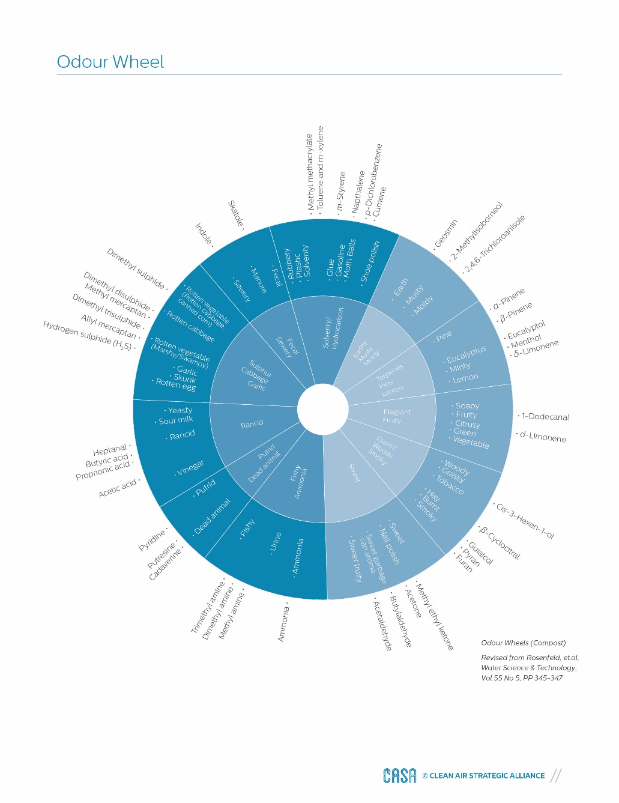](http://casahome.org/Portals/0/DMX/OMT%20GPG/Odour%20Wheel.pdf?timestamp=1445893546957)**

**Categorical Scale Analysis**

Odour character is a nominal (categorical) scale of measurement and requires sensory (subjective) methods compared with odour detection threshold value determinations (objective). Sensory methods include odour intensity and hedonic tone. Determination of sensory parameters is most useful for samples that are collected undiluted at a receptor (rather than at an emission source) and then evaluated by an odour panel without dilution.

**Olfactometry**

Olfactometry is considered the best available approach for measuring odours directly, to objectively quantify the perception of odours as, in many cases, the detection limits of analytical instruments for individual or multiple odorants are higher (worse) than the human nose (Pandey et al., 2012). In olfactometry, the odour sample is diluted with odour‐free air, according to precise ratios, to determine odour concentrations using an odour panel.

**Community Odour Assessment**

Community surveys can do more than provide information on nominal odour levels. They are valuable sources of descriptive data that can be used in odour descriptor wheel analysis and categorical scale analysis.

**Odour Diary**

An odour diary is a record of odour (and especially odour episodes) by individuals living near sources. Typically diaries are kept by those experiencing odour annoyances. Characteristics of the odour are recorded such as intensity, character, duration and pleasantness. Date and time of the odour episode should also be recorded.

Dispersion Modelling for Odour and Odorants

**Modelling Types**

Odour models can be classified according to their working principles (Olesen et al., 2005):  

* Gaussian plume models assume that dispersion takes place in odorant plumes with specific geometry (Gaussian distribution). This kind of model is sometimes called a "lighthouse" model where the plume moves from the source in the direction of the wind, independently in each hour.
* Gaussian puff models assume the odorant is emitted as series of puffs. This allows each puff to travel a curved path as the wind direction changes.
* Lagrangian particle models assume the release of a large number of individual virtual particles whose fate is followed and summarized. According to the Lagrangian approach, virtual particles follow a wind field modified by turbulence.
* Computational Fluid Dynamics (CFD) models are sophisticated codes for fluid dynamics and transport problems, based on numerical solution of the governing fluid flow and dispersion equations (Pope, 2004). These models are useful for near‐field application in the vicinity of buildings and complex structures. CFD models could be used for odour modelling but they are complicated (Prata et al., 2014) and, therefore, they are rarely, if ever, used for odour assessments.
* In Eulerian models, emissions are assigned to grids rather than to specific geographic coordinates. Eulerian models were typically designed for long range transport and include complex chemistry. They do not track odorant plumes from specific sources. As such, they are best suited for regional modelling rather than odour assessments.

**Model Input Requirements**

To run dispersion models for odour assessments, the following inputs are generally required:

* Emission and source parameters, including nearby buildings
* Meteorological data
* Terrain data
* Land use characteristics

Trend Analysis

Trend analysis for patterns in odour data could take the following forms"

* Temporal trends in odour concentrations or odour character measured at specific locations
* Identification of potential upwind source regions based on measurements at one or more locations
* Spatial trends in odour concentrations or odour character

[**Back to Top of Page**](http://casahome.org/CurrentInitiatives/GoodPracticesGuideforOdourManagementinAlberta/OdourAssessments.aspx)

TOOLS USE

**Purpose**

The Understanding Odour and Odour Assessments information in this Good Practices Guide provides context and options on odour issues and their assessment. The purpose of the following odour assessment “Tools Use” Guide is to help determine which specific odour assessment options should be considered in which circumstances. It is recommended that the user reads background material prior to using this guide to gain a better understanding of its content:

**Using the ‘Tools Use’ Guide**

The following approach is suggested:

1. Identify the purpose of the odour assessment using the following chart.

2. Review the suggested steps in the assessment for the selected odour assessment purpose.

3. For each step, examine the matrix of tool options in Table 3 and Table 4 for that step and identify the possible tools that meet your needs.

As a simplified example, if the purpose is to verify an odour complaint, choose a non‐analytical assessment tool as a first step. An odour wheel may confirm that the “strong solvent smell” complaint may be due to toluene or xylene emissions. A follow-up ambient measurement program at the location of the complaint could involve the collection of a number of canister samples followed by laboratory analysis for the odorants of interest (and others). The resultant odorant concentrations and frequency of high concentrations could be compared to established odour thresholds. If the measurements suggest that a specific source may be responsible for the observations, a source measurement program may be appropriate. At each step, the guide offers options based on such factors as cost, the type of source, and whether odour or odorants is the issue. A glossary has been provided in this guide to assist with understanding terms and acronyms.

*Note: Depending on the nature of the odour issue, a more robust assessment plan may be required which may involve more and/or different steps than suggested here.*

**How will the results be interpreted?**

There is a wide range in the information output from the various tools, and the interpretations may vary just as widely. For example, the output of a continuous ambient monitor will be a series of concentration measurements for an odorant (such as H2S). The data can be compared to odour detection thresholds, or summarized to establish frequencies of observations above thresholds. When coupled with wind data measured simultaneously, a likely direction from which odorants emanate may be determined. As a second example, the information output of an odour wheel is the identification of a possible odorant (e.g., H2S) based on the characteristics of the odour (e.g., rotten eggs) as determined by an individual. In many cases, the addition of a dispersion modelling step will provide greater understanding of the issue, by identifying odour or odorant hot‐spots or conditions under which high odour is predicted, that might not be identified by monitoring alone.

**Who should use the guide?**

This guide is primarily intended for non‐experts who are looking for general guidance on the steps that should be considered to address different types of odour issues and management considerations. This could include representatives of municipalities dealing with odour complaints, industry wishing to change their operations, communities with odour concerns, provincial government and regulators.

|  |  |
| --- | --- |
| PURPOSE OF ODOUR ASSESSMENT | SUGGESTED STEPS |
| To verify and investigate odour complaints | 1. Non‐analytical assessment  2. Ambient sampling and measurement  3. Source sampling and measurement |
| To comply with conditions outlined in operating/industrial permits | 1. Source sampling and measurement  2. Ambient sampling and measurement |
| To determine compliance with odour legislation | 1. Source sampling and measurement  2. Ambient sampling and measurement |
| To assess long-term odour exposure levels in an area | 1. Non‐analytical assessment  2. Ambient sampling and measurement |
| To rank potential odour sources for mitigation purposes | 1. Source sampling and measurements (OU or individual compounds) |
| To determine background odour concentrations before building a new facility | 1. Ambient sampling and measurement |
| To determine the off‐site odour impact from existing operations | 1. Non‐analytical assessment  2. Ambient sampling and measurement |
| To determine the expected changes in off‐site odours resulting from new facilities, expansions of existing facilities or other operational changes | 1. Source sampling and measurement  2. Ambient sampling and measurement  3. Dispersion modelling |

Section 6 of [***Review of Odour Assessment Tools and Practices for Alberta***](http://casahome.org/LinkClick.aspx?fileticket=P-9teU5NWU4%3d&portalid=0&timestamp=1436887677750) provides more detail about costs, accuracy, ease of use, limitations and other factors about each tool.

[**Back to Top of Page**](http://casahome.org/CurrentInitiatives/GoodPracticesGuideforOdourManagementinAlberta/OdourAssessments.aspx)

**[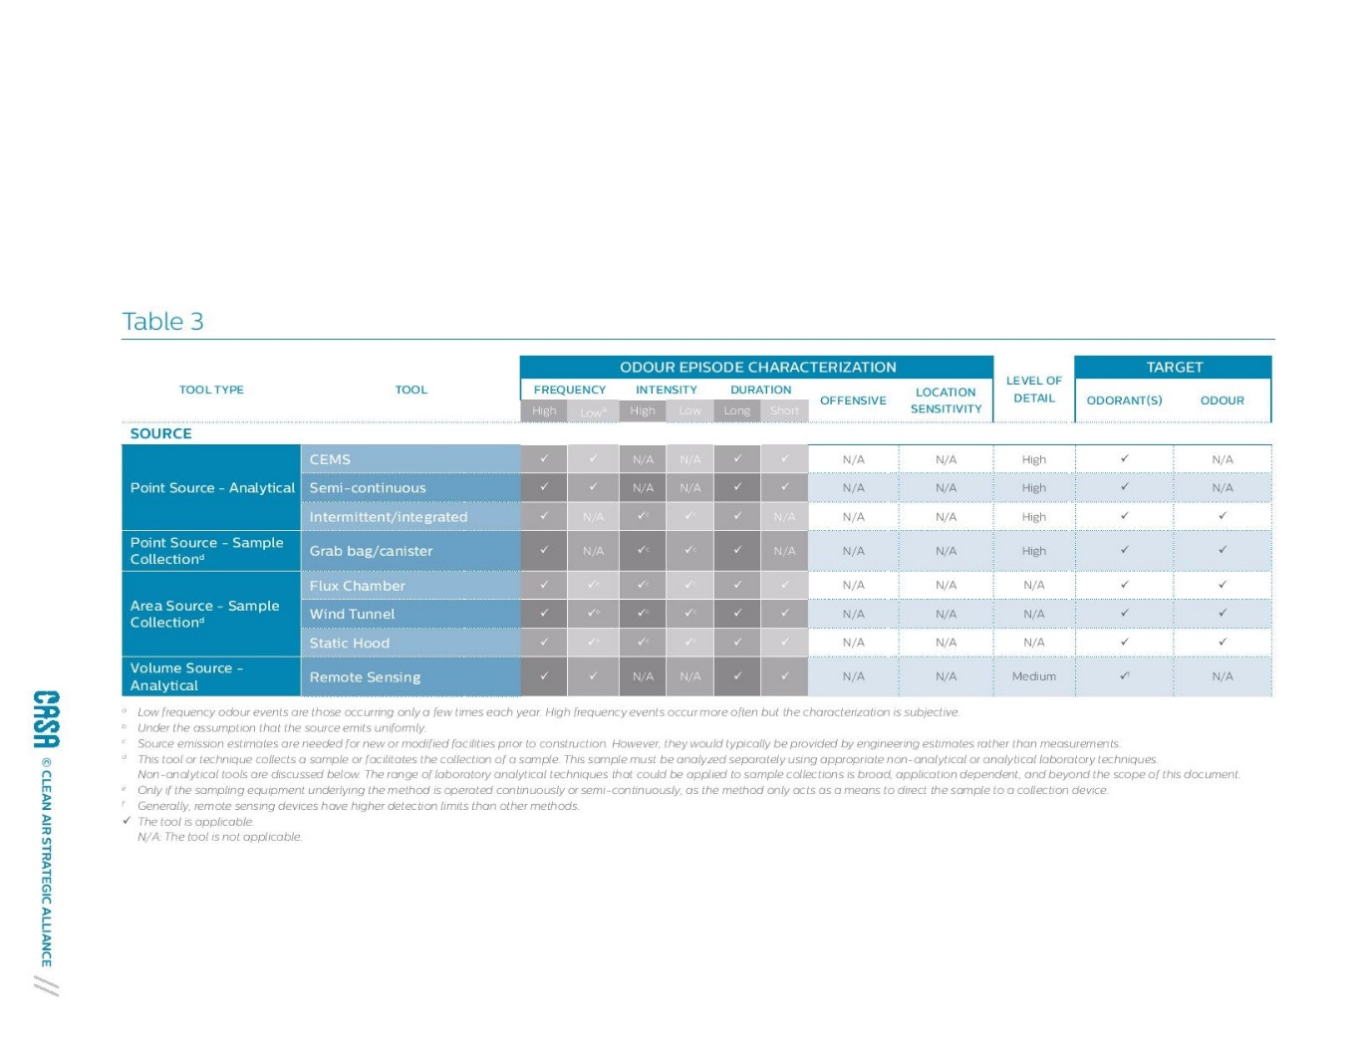](http://casahome.org/Portals/0/DMX/OMT%20GPG/CASA_GPG_webversion_Table03.pdf?timestamp=1446148175406)**  
**[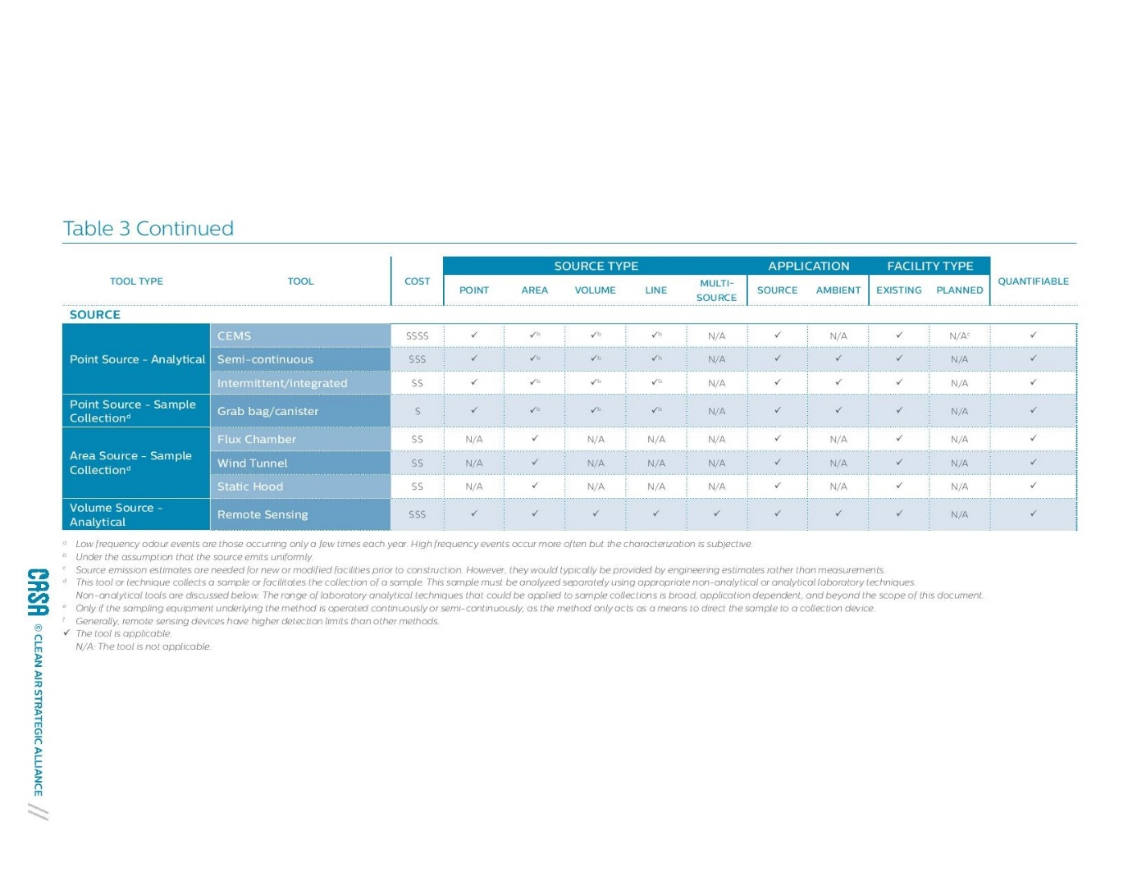](http://casahome.org/Portals/0/DMX/OMT%20GPG/CASA_GPG_webversion_Table03.pdf?timestamp=1446148175406)**

**[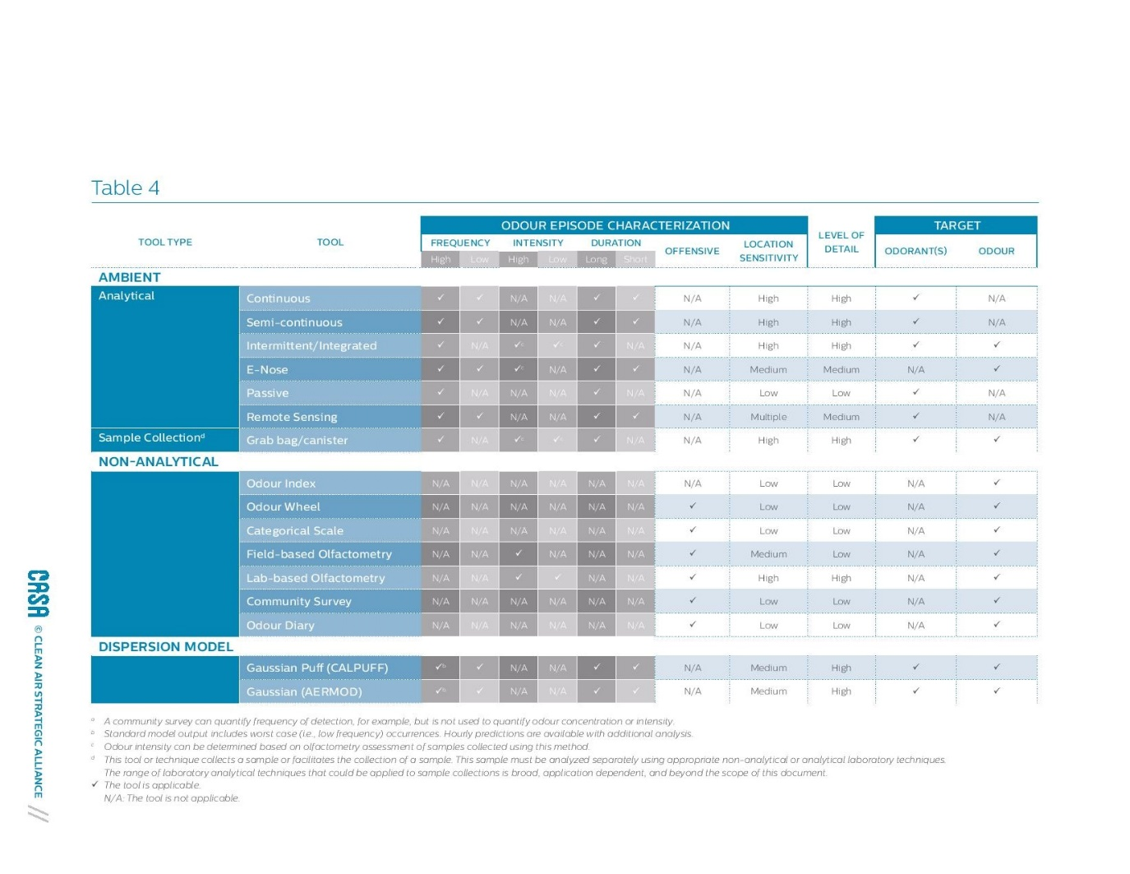](http://casahome.org/Portals/0/DMX/OMT%20GPG/CASA_GPG_webversion_Table04.pdf?timestamp=1446148293993)**  
**[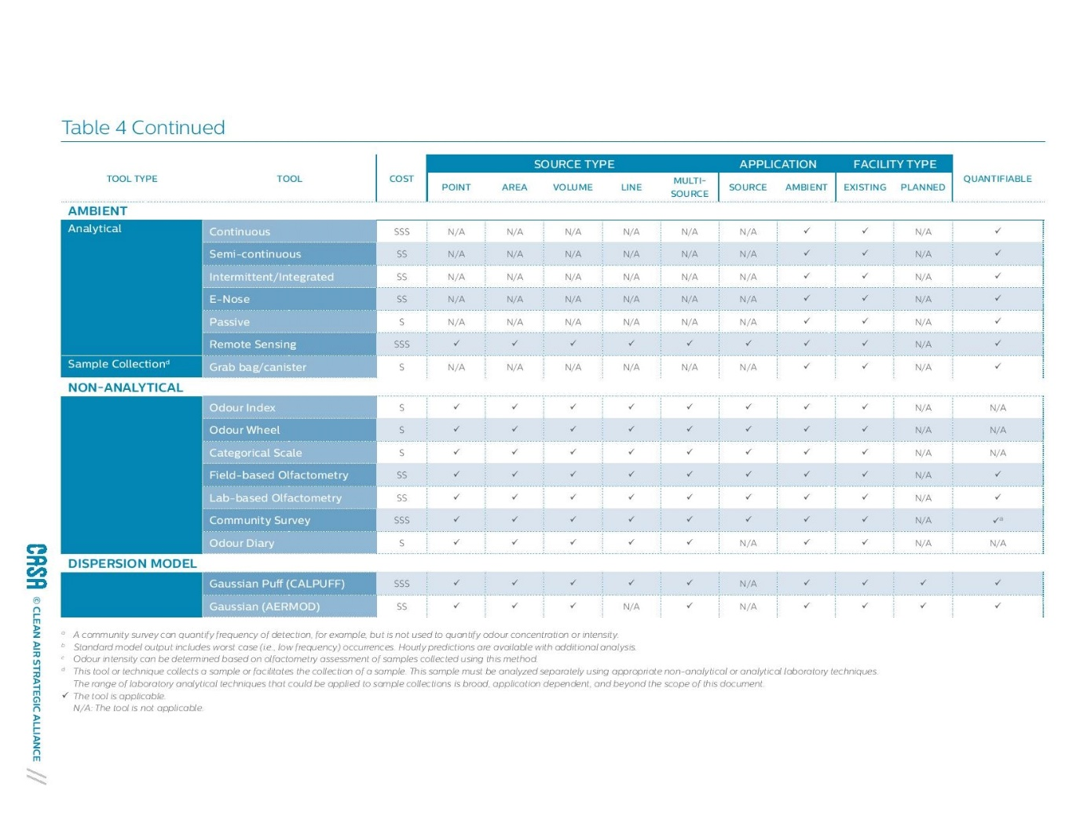](http://casahome.org/Portals/0/DMX/OMT%20GPG/CASA_GPG_webversion_Table04.pdf?timestamp=1446148293993)**

[**Back to Top of Page**](http://casahome.org/CurrentInitiatives/GoodPracticesGuideforOdourManagementinAlberta/OdourAssessments.aspx)